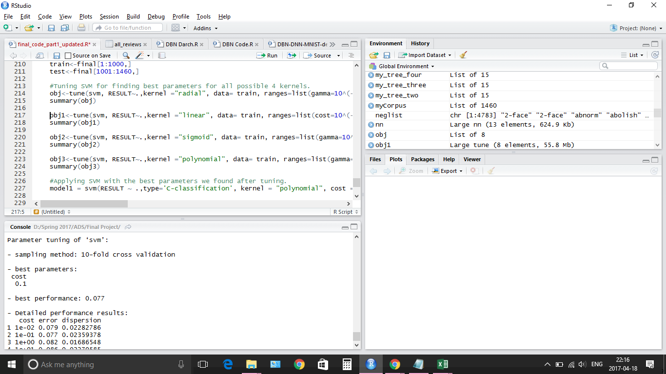

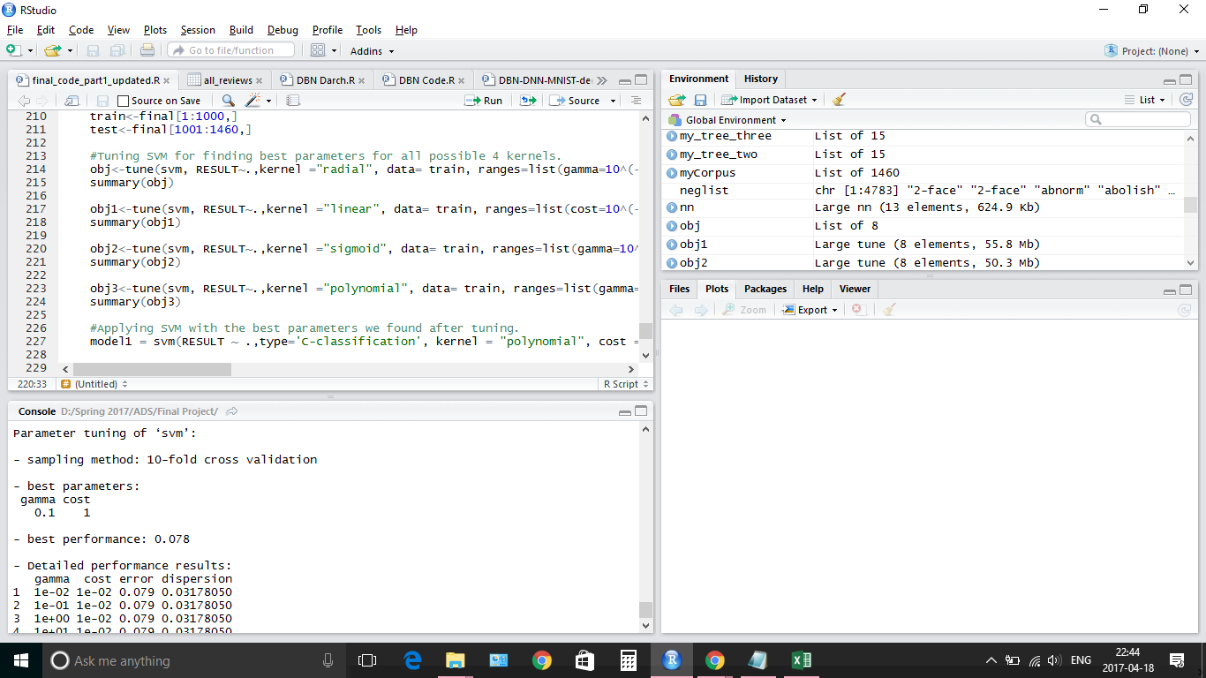

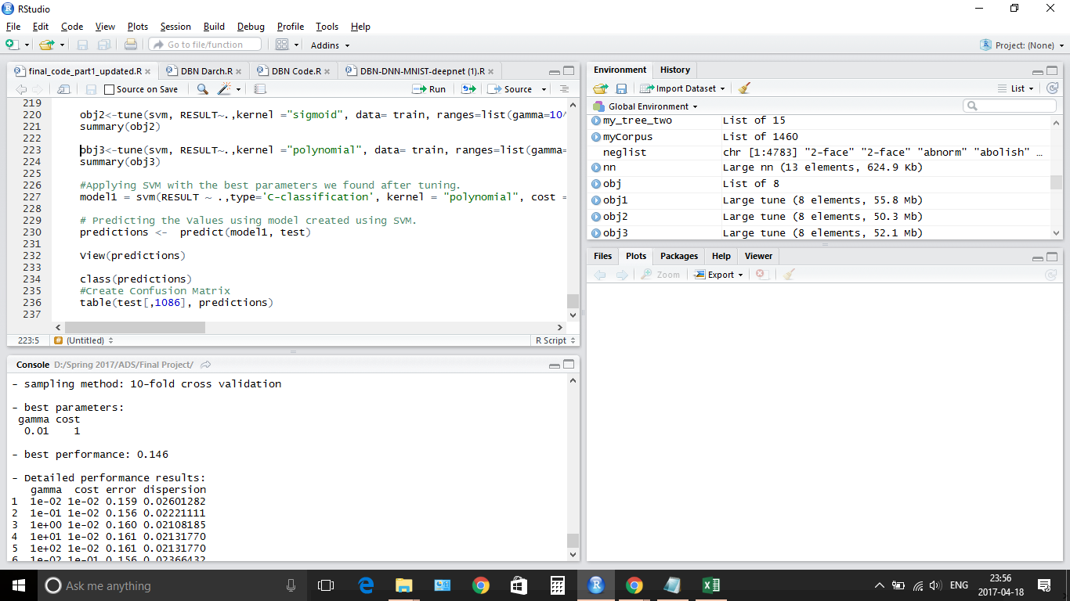

> table(test[,6251], predictions)

predictions

negative neutral positive

negative 1 9 22

neutral 0 9 62

positive 1 5 891

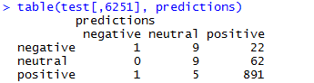

4551 157 292

P Neg Neu

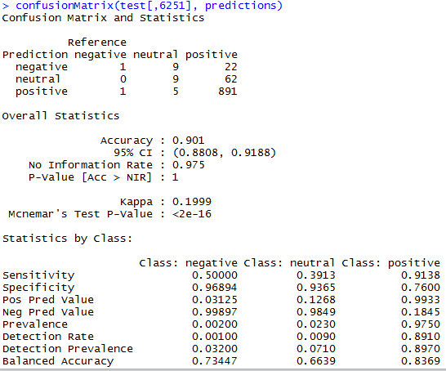

* A **Support Vector Machine** (**SVM**) is a discriminative classifier formally defined by a separating **hyperplane**. In other words, given labeled training data (supervised learning), the algorithm outputs an optimal hyperplane which categorizes new examples.
* **Applications**: text categorization, image classification, bioinformatics, hand-written character recognition.
* **Limitations:** Sensitive to Noise, Choice of Kernel, Speed and Size of Train and Test
* **Future Directions:** Try more range for tuning the kernel.

**Limitations: Sensitive to Noise, Choice of Kernel, Speed and Size of Train and Test**

**Future Directions: Try more range for tuning the kernel.**

4551 157 292

Pos Neg Neu